Technology Advisory Board (TAB) Committee
Thursday, September 25, 2025
Via Teams

Meeting Minutes

Attendees: Larry Jennings, Meghan Wilkey, Bright Daniel, Dan Green, Uduak David, Mike Rogers, Jolyon Grey, Dr. Emily Paskewitz, Ethan Lindsey, Olena Korotych

Absent: Ramon Padilla, Dan Harder, Cris Emberton

Welcome
- Larry Jennings welcomes everyone to the TAB Committee
- This meeting began at 4:05pm

Agenda
- Welcome and Introductions
- College/Department Award Cycle
See below FY26 Award Process
- Other Business

Welcome and Introductions
Larry introduces himself and thanks the committee for participating. He then goes through the agenda and asks everyone to introduce themselves.

FY26 Budget
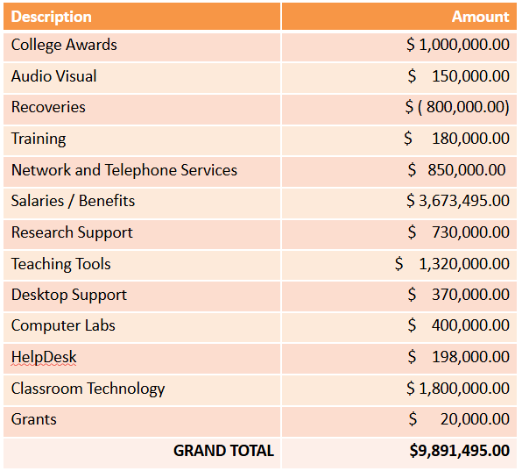

Stay up to date with OIT
Visit oit.utk.edu/about​ for OIT Weekly Tech News
Visit oit.utk.edu/about for OIT Instruction & Research News
Bookmark oit.utk.edu/news and check back often for OIT News
Visit help.utk.edu/status to see IT Systems Status Center

FY25 Award Process
- February 2026 – Tech Fee request letters sent to the Colleges/Departments​
- April 2026 – Deadline for submission of all funding request documents​
- April 2026 – TAB makes allocations at the April meeting​
- May 2026 – Colleges/Departments receive award verifications & purchasing guidelines​
- July 2026 – March 2027 – Colleges/Departments make purchases​
- July 2026– March 2027 – Reimbursement for purchases are made following the guidelines

Meeting adjourned at 4:32pm
  - Next meeting – Thursday, October 23, 2025, via Teams

TAB meeting calendar (via Teams)
- September 25, 2025
- October 23, 2025
- November 20, 2025
- No December meeting due to Winter Holiday
- January 22, 2026
- February 26, 2026
- March 26, 2026
- April 23, 2026

Minutes submitted by: Meghan Wilkey

