Technology Advisory Board (TAB) Committee
Thursday, January 22, 2026
Via Teams

Meeting Minutes

Attendees: Larry Jennings, Meghan Wilkey, Bright Daniel, Mike Rogers, Ethan Lindsey, Uduak David, Dan Green, Dr. Emily Paskewitz, Jolyon Grey, Cris Emberton

Absent: Ramon Padilla, Dan Harder, Olena Korotych

Welcome
- Larry Jennings welcomes everyone to the TAB Committee
- This meeting began at 4:02 pm

Agenda
- Welcome
- Wireless @ UTK
- FY27 College/Department Award Process

Wireless @ UTK
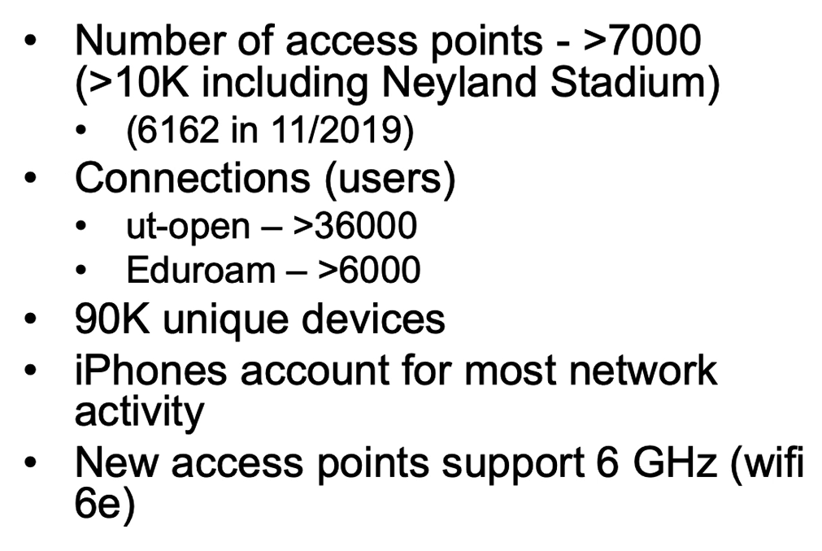

FY25 Award Process
- January 30, 2026 – Tech Fee request letters sent to the Colleges/Departments​
- April 7, 2026 – Deadline for submission of all funding request documents​
- April 23, 2026 – TAB makes allocations at the April meeting​
- May 2026 – Colleges/Departments receive award verifications & purchasing guidelines​
- July 2026 – March 2027 – Colleges/Departments make purchases​
- July 2026– March 2027 – Reimbursements for purchases are made following the guidelines

Stay up to date with OIT
Visit oit.utk.edu/about​ for OIT Weekly Tech News
Visit oit.utk.edu/about for OIT Instruction & Research News
Bookmark oit.utk.edu/news and check back often for OIT News
Visit help.utk.edu/status to see IT Systems Status Center

Meeting adjourned at 4:32 pm
  - Next meeting – Thursday, February 26, 2026 via Teams

TAB meeting calendar (via Teams)
- September 25, 2025
- October 23, 2025
- November 20, 2025
- No December meeting due to the Winter Holiday
- January 22, 2026
- February 26, 2026
- March 26, 2026
- April 23, 2026

Minutes submitted by: Meghan Wilkey

