Technology Advisory Board (TAB) Committee
Thursday, April 23, 2026
Via Teams

Meeting Minutes

Attendees: Larry Jennings, Meghan Wilkey, Uduak David, Jolyn Grey, Bright Daniel, Ethan Lindsey, Mike Rogers, Dan Green, Emily Paskewitz, Olena Korotych

Absent: Chris Emberton,

Welcome
- Larry Jennings welcomes everyone to the TAB Committee.
- This meeting began at 4:00 pm
Agenda
- Annual OIT Customer Satisfaction Survey
- Review of the Fee Allocation Spreadsheet

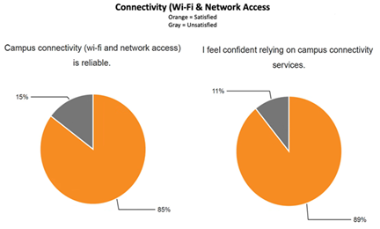
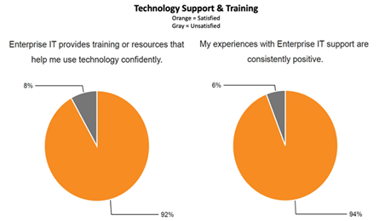
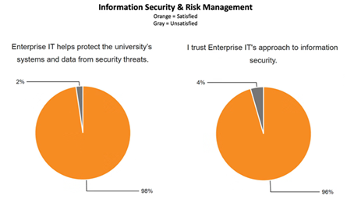
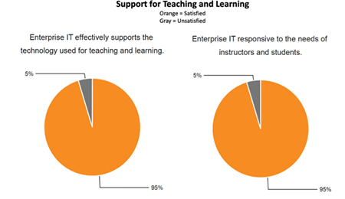
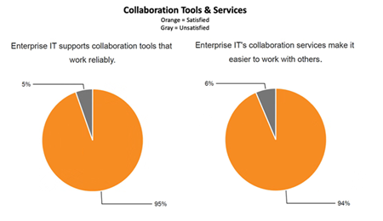

Review of the Fee Allocation Spreadsheet

Larry explains that we had about $2.7M in tech fee requests from the colleges/departments. This year, we can fund up to $1.3M in requests. Adobe requests are not counted against the $1.3M. Larry explains that he asks colleges for a priority list since they know what they need the most. We are rarely unable to fund the number 1 request. Ethan and Emily voice concerns about specific requests, and Larry advises that we can reach out to colleges for more information. Olena asks about Adobe license requests and incorporating AI into classrooms with similar licenses. Larry advises that a college can submit the request as a software or service that is necessary and directs her to the University's AI hub. Jolyon asks about another request where the scope of utilization doesn’t match the request. Larry explains we can reach out to them to get more context, and he will review any requests that members have concerns about. Dan asks what our criteria are for evaluating the requests and what we see as a priority. Larry advises he relies on the college to give their priority and we consider enrolment. Mike asks why some colleges put priority on department level rather than college level and how we consider that. Larry prefers the college to prioritize; however, some colleges feel that it is impractical to condense it to that level and Larry does see the benefits of guidance within the larger colleges. Joe asks when we are prioritizing, do we have any mandate that puts technology into the hands of students more than staff? Larry explains we do not use the tech fee for staff, and it is targeted to students and their teachers.

Larry asks for a vote to confirm the approval of recommendations for college awards.

TAB approved recommendations with the condition of following up with a few requests for clarification.

Meeting adjourned at 4:50 PM
  - This is the final meeting for the FY26 year. Thank you to all our board members for your input and help!

Minutes submitted by: Meghan Wilkey

